Home Health Access for Rural Coloradoans with Medicare

Aim:
- Increased access to high-quality home health services for rural Medicare beneficiaries in Colorado.
- “Almost 1 in 4 Medicare Beneficiaries reside in rural areas, yet they face barriers to healthcare access” (Gozalo et al., 2020, p. 663).
- 47 out of the 64 counties are designated as rural or frontier (<6 people per square mile) (Colorado Rural Health Center, 2022).

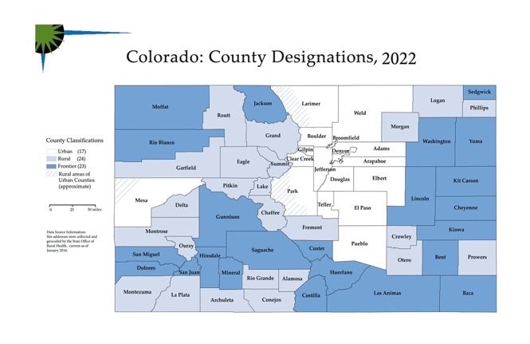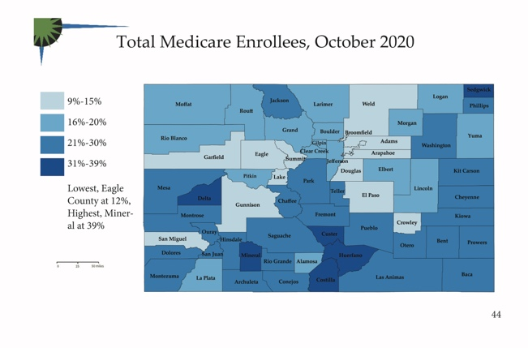
County Designations: White = Urban; Light blue = Rural; Dark Blue = Frontier
Maps from: https://coruralhealth.org/resources/maps-resource

- 21% of the rural population is over 65 years of age (Colorado Rural Health Center, 2022).

Problem:
- In the U.S., “94 percent of counties with no home health agencies were rural” (Frogner et al., 2020, p.953).
- Medicare beneficiaries living in rural areas are more ill and at a higher risk for hospitalizations than those living in urban areas (Frogner et al., 2020).
  - A recent study showed that rural Medicare beneficiaries using home health had lower rates of hospitalization (Chen et al., 2020).
- To increase access to home health services for Medicare beneficiaries in rural areas, The Centers for Medicare and Medicaid Services (CMS) started the rural add-on payments.
  - A study done in 2020 demonstrated the positive effect of the CMS rural add-on payments. Utilization increased by 0.8% for rural beneficiaries (Gozalo et al., 2020).
  - Another recent study showed that rural add-on payments greater than 5% were needed for home health agencies to maintain and/or increase services to rural Medicare beneficiaries (Frogner et al., 2020).
- CMS rural add-on payments to home health care agencies serving Medicare beneficiaries are ending this year (Chen et al., 2020).
  - This might cause the closure of both facility-based and free-standing home health agencies in rural areas and deter urban-based ones from providing services to rural areas (Chen et al. 2020).
- On March 7, 2022, Colorado House Bill 22-1188, ARPA American Rescue Plan Act Money For Home- And Community-based Services was passed.
  - Designated money in the ARPA account is to be used for community and home health services.
- Since the CMS rural add-on payments are ending this year Colorado House Bill 22-1188 needs to be amended.

Recommendation:
- Senators on the Health & Human Services Committee place this issue on their agenda and fully research it.
- Recruit representatives and fellow Senators to sponsor an amendment to Colorado House Bill 22-1188 to dedicate a portion of the funding to support home health agencies that serve rural Medicare beneficiaries.
  - Within the amendment create a committee to approve and monitor the home health agencies receiving funding to ensure that they are spending the money to better serve rural Medicare beneficiaries.
- Senators on the Health & Human Services Committee along with representative and fellow Senators present the bill amendment to the House of Representatives.

References
Chen, H., Landes, R. D., Schuldt, & Tilford, J. M. (2020). Quality performance of rural and urban home health agencies: implications for rural add-on payment policies. The Journal of Rural Health, 36, 423-432.
Colorado House Bill 22-1188, ARPA American Rescue Plan Act Money For Home- And Community-based Services, 3/7/2022. https://leg.colorado.gov/bills/hb22-1188
Colorado Rural Health Center The State Office of Rural Health. (2022). Snapshot of rural health in Colorado 2022. Colorado Rural Health Center The State Office of Rural Health. https://coruralhealth.org/snapshot-of-rural-health
Frogner, B. K., Mroz, T. M., & Patterson, D. G. (2020, June). The impact of Medicare’s rural add-on payments on supply of home health agencies serving rural counties. Health affairs (Project Hope), 39(6), 949-957.
Gozalo, P. L., Loomer, L., Mor, V., Mroz, T. M., & Rahman, M. (2020, March). Do higher payments increase access to post-acute home health care for rural Medicare beneficiaries?. Journal of the American Geriatrics Society, 68(3), 663-664.

